ETC2410 Assignment 2

David Kontrobarsky, Amy Corrone, Wendy Huynh, Chandralekha Segaran, Joshua Bunce

31 August 2018

**Introduction**

The Capital Asset Pricing Model (CAPM) is utilised to quantify the rate of return that is required by a asset considering its systematic risk. The model simplifies the relationship between the risk-free rate (Rf), market rate (Rm) and the β of the asset, as defined as the risk of the asset, to be linear. It is often utilised to measure the performance of managed portfolios and funds of mutual size. For simplification, CAPM applies many assumptions. This includes that markets and risk-free rate is constant, the holding period is constant, and tax is not considered. The advantages of CAPM include the usage of systematic risk, as it cannot be mitigated or diversified, and the simplicity to compute and understand. However, the simplification relies on unrealistic expectations. The market rate is often based on historical data, and thus unrepresentative of future market returns, and determining the criteria to compute the β of the asset is subjective to each firm and thus problematic. The Fama French model includes the addition of two variables, the size and value premium. This may help to offset Fama and French’s findings that the returns on the CAPM model from portfolios with only one Beta are highly different compared to what the model predicts. The residuals for both portfolios with the lowest and highest Betas remain at around 3%, suggesting that further interpretation may need to be carried out (Fama and French, 2004). This allows for adjustment for small-cap stocks outperforming large-cap stocks. The objective of this empirical analysis is to determine what risk factors are important in determining the price of an asset or portfolio and whether the effects of these factors change dependant on the state of the economy and the industries being considered.

**Data:**

The data set contains three different pieces of data. All of the data found comes from Kenneth R.French’s data library at <http://mba.tuck.dartmouth.edu/pages/faculty/ken.french/data_library.html>. Together with Eugene Fama, French has been studying the calculation of average returns in a portfolio of stocks for over 50 years. This helps to quantify where seasonality and model prediction can be found in the first place. For the Fama-French model, the definitions of each of the variables aside from the market risk premium comes from Fama & French’s paper ‘Common risk factors on the returns of stocks and bonds’ (1992).

Therefore, for each part of the report the variables are defined as such:

**2 Industry Portfolios** – The average returns from 2 different industries grouped together from Jan-1989 to Dec-2009 from stocks found in the NYSE, AMEX & NASDAQ. Each stock is assigned to an industry portfolio at June of each year based on its four-digit SIC code, which are either Compustat or CRSP SIC codes (Fama & French, 2018).

These portfolios are:

1. **Cnsmr** – Consumer Durables, Non-Durables, Wholesale, Retail, and Some Services (Laundries, Repair Shops)
2. **HiTec** Business Equipment, Telephone and Television Transmission

Fama & French’s model combines, “two easily measured variables… to capture the cross-sectional variation in average stock returns” (Fama & French, 1992b, p427). These two variables must be defined. The variables used in analysing the capital asset pricing model (CAPM) are:

1. **Rf –** this is the risk-free rate of return on stocks from the period Jul-1926 to Feb-2018. This is usually measured through the 5 year treasury bond return for each time period, as we are analysing US stocks and portfolios
2. **Rf)** – this is equal to the excess return on the market for a particular asset, i.e. the difference between the return of a market asset and a risk-free asset. We would expect to see this as a positive number otherwise there is no incentive to invest in the asset.
3. **–** Small minus big is the measure for size in the Fama-French model. It is the average return on the three small portfolios minus the average return on the three big portfolios (French, 2018). It is calculated using the formula

*SMB =1/3 (Small Value + Small Neutral + Small Growth)  - 1/3 (Big Value + Big Neutral + Big Growth).*

1. **HML –** High minus low is the measure for book-to-market equity or value of a portfolio as found in the Fama-French model. This is measured through the average return of the two value portfolios minus the average return of the two growth portfolios. It is calculated using the formula

HML = ½(small value + big value) – ½ (small growth 3+ big growth)

is the monthly excess return for either Cnsmr or Hitec

**Regression results**

**Fama-French model**

**Testing for Heteroskedasticity and serial correlation in the data**

**White test for heteroskedasticity**

These tests are conducted to ensure standard errors and t-stats are accurate for hypothesis testing of the model parameters. Breusch-Pagan assumes that if there is heteroskedasticity then it is a linear effect of the independent variables

|  |  |  |
| --- | --- | --- |
|  | PERIOD 1 (JAN 1989 – DEC 1997) | PERIOD 2 (JAN 1998 – DEC 2009) |
| CNSMR |  |  |
| HITEC |  |  |

Despite the contradiction between White and Breusch-Pagan for two of these tests, it is the conservative approach to assume heteroskedasticity.

**Testing for serial correlation using Breusch-Godfrey**

The assumption is made that if serial correlation is present then the errors are autoregressive of order q, denoted by AR(q). Since the returns data is monthly, the alternative that errors are AR(12) will be tested. It is important to determine the AR model before testing.

Run the following regression model by first running the original model and obtaining residuals

+ + + +

Note that Eviews sets the 12 missing lagged values to 0 which changes slightly so the original number of observation is used for calculating the test statistic.

|  |  |  |
| --- | --- | --- |
|  | PERIOD 1 (JAN 1989 – DEC 1997) | PERIOD 2 (JAN 1998 – DEC 2009) |
| CNSMR |  |  |
| HITEC |  |  |

**As a result of the preceding tests which determined the presence of heteroskedasticity for the Hitech industry in both time periods and no evidence of serial correlation, the standard errors were transformed as necessary. Namely, white standard errors (HC1) will be used which corrects for the degrees of freedom compared to HC0.**

**B(ii) – Testing parameter significance**

**Fama French Model**

**Period 1 Jan 1989 – Dec 1997**

|  |  |
| --- | --- |
|  | PERIOD 1 (JAN 1989 – DEC 1997) |
| CNSMR | (0.065)  (0.042)  (0.053)  (0.145)  At 5% significance, only excess returns on the market (Mkt-Rf) is deemed to be significant in determining monthly excess return ( for Cnsmr between January 1989 and December 1997. |
| HITEC | (0.098)  (0.080)  (0.059)  (0.170)  At 5% significance, only excess returns on the market (Mkt-Rf) is deemed to be significant in determining monthly excess return ( for HiTec between January 1989 and December 1997. |

**Period 2 Jan 1998 – Dec 2009**

|  |  |
| --- | --- |
|  | PERIOD 2 (JAN 1989 – DEC 1997) |
| CNSMR | (0.034)  (0.047)  (0.044)  (0.163)  ,  At 5% significance, excess returns on the market (Mkt-Rf) and High Minus Low (HML) are deemed to be significant in determining monthly excess return ( for Cnsmr between January 1998 and December 2009 |
| HITEC | (0.054)  (0.062)  (0.063)  (0.204)  At 5% significance, excess returns on the market (Mkt-Rf) and High Minus Low (HML) are deemed to be significant in determining monthly excess return ( for HiTec between January 1998 and December 2009. |

**B(iii)**

**Testing significance of the intercept**

|  |  |  |
| --- | --- | --- |
|  | PERIOD 1 (JAN 1989 – DEC 1997) | PERIOD 2 (JAN 1998 – DEC 2009) |
| CNSMR |  |  |
| HITEC |  |  |

**Testing coefficient of the market factor is equal to unity**

If the market risk factor, is equal to 1 then that investment is as volatile as the overall market and it’s price moves with the market. This would be true if the portfolio represents the market. If then the portfolio is more volatile than the market and less volatile if This is known as the beta of the portfolio.

|  |  |  |
| --- | --- | --- |
|  | PERIOD 1 (JAN 1989 – DEC 1997) | PERIOD 2 (JAN 1998 – DEC 2009) |
| CNSMR |  |  |
| HITEC |  |  |

**Part C – Testing significance of SMB and HML**

SMB and HML are additional risk factors included in the Fama-French model but not in the CAPM model. If these factors are significant, it may suggest the Fama-French model is a better predictor of excess return than CAPM.

|  |  |  |
| --- | --- | --- |
|  | PERIOD 1 (JAN 1989 – DEC 1997) | PERIOD 2 (JAN 1998 – DEC 2009) |
| CNSMR |  |  |
| HITEC |  |  |

**Part D – Testing for structural change after 1997**

The period from Jan-1989 to Dec-1997 is characterised as relatively stable while period Jan-1998 to Dec-2009 saw the Russian and the Long-Term Capital crises which originated in bond markets but rapidly transmitted through international equity markets, the burst of the Dotcom bubble and 9/11 terrorist attacks in the US, and the sub-prime mortgage crisis also in the US, followed by the global Financial meltdown and economic recession.

We will test if these events caused a structural change in the markets.

The dummy variable ‘post1997’ is defined:

Both a change in slope of all independent variables and intercept is tested for:

F-test to assess the joint significance of the dummy variable terms

**Cnsmr**

There is evidence sufficient to suggest a structural change in January 1998 for the Cnsmr portfolio.

**Hitec**

There is evidence sufficient to suggest a structural change in January 1998 for the Hitec portfolio.

The conclusions of this test i.e. that both portfolios have structural change after December 1997 is supportive of the previous analysis. HML is determined to be a significant indicator of excess returns in period 2 but not in period 1 and the coefficient of the market factor is deemed to be significantly different from unity in period 2 but not in period 1 for both industries and portfolios. Furthermore, the likelihood of SMB and HML significant determinants of excess returns increases greatly in the 2nd period.

**Discussion and concluding remarks**

Analysis in part C shows that the extra factors that form the Fama-French model i.e HML and SMB are far more significant in period 2 compared to period 1. The 2nd period of analysis (1998 - 2009) is generally seen as a far more volatile period for the markets due to the subprime mortgage crisis followed by the global financial meltdown and economic recession. As such, the analysis suggests that in times of market volatility, the predictive power of the Fama-French model is significantly better to that of CAPM. However, during economic stability, Fama-French and CAPM often provide similar predictions.

This makes sense intuitively as under unstable economic conditions, the volatility of the portfolio’s is more likely to be different than the market risk. Therefore, the market factor will have less predictive power and introducing additional risk factors will help to explain more of the variation in excess returns. This is supported by evidence in part D that finds a significant structural change after December 1997.

Fundamentally, the Fama-French model would be expcted to show greater accuracy as it takes into account additional important factors in comparison to the CAPM. Nevertheless, this model is much more complex than CAPM and it takes more time to compute as well. In practice, Fama-French may not find be as cost effective as it requires the collection of additional information.

Whilst the CAPM represents simplicity allowing investors to more easily determine whether or not the return on their stocks will be positive, the Fama-French model represents these returns to a higher degree of precision. Although, Fama-French also has problems as the coefficient of SMB is often found to be insignificant in regressions.

Ultimately, since none of the intercepts for CAPM regressions were significantly different from zero, there is no empirical evidence against the theoretical framework of CAPM.

**References**

Davidson, R. and J. G. MacKinnon (1993). *Estimation and Inference in Econometrics*. New York: Oxford University Press.

<https://www.sciencedirect.com/science/article/pii/S1057521904001085>

https://businessperspectives.org/images/pdf/applications/publishing/templates/article/assets/4288/pmf_2012_02_Blanco.pdf

Appendix

Cnsmr period 1 breusch pagan test auxiliary regression

HiTEC period 1 breusch pagan test auxiliary regression

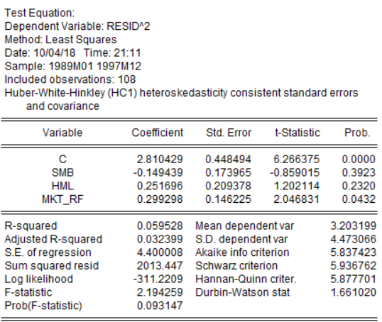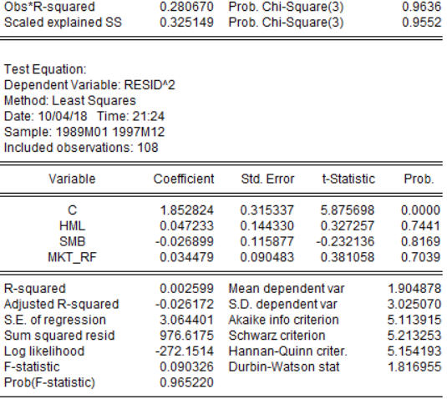

HiTec period 2 breusch pagan test auxiliary regression

Cnsmr period 2 breusch pagan test auxiliary regression

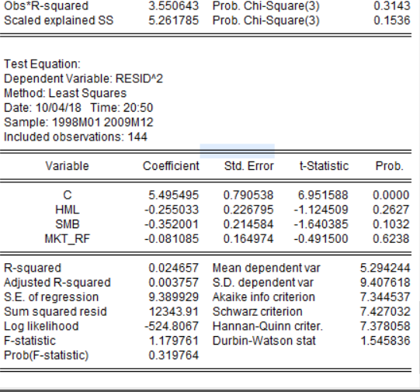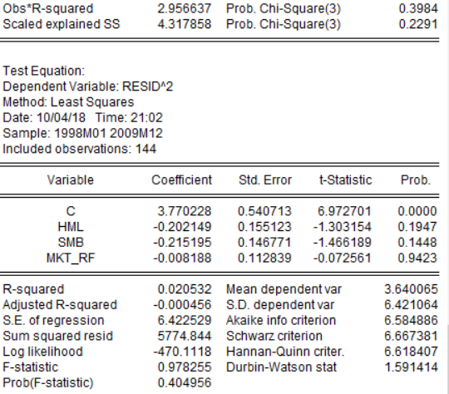

White test for period 1 hitec

White test for period 2 cnsmr

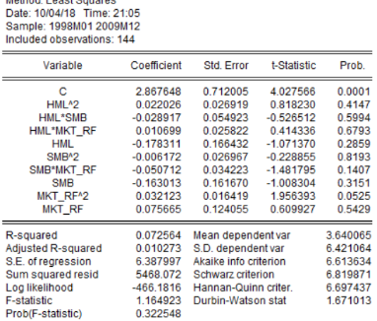

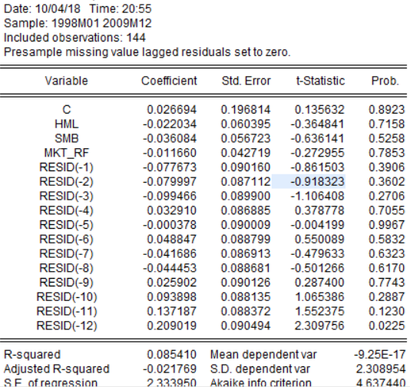

White test for period 2 hitec:

BG test for period 1 cnsmr

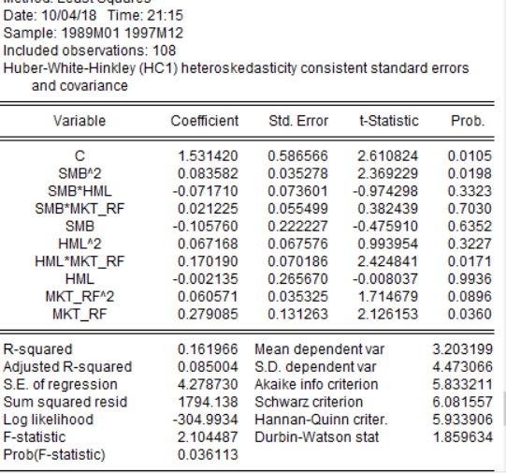

BG test for period 1 hitec

BG test for period 2 hitec

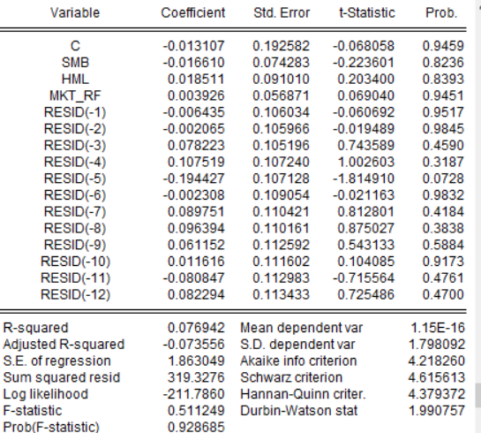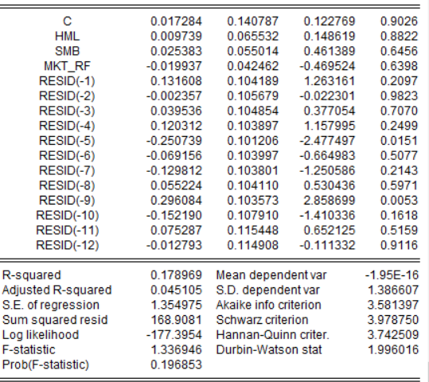

FF model cnsmr period 1

FF model hitec period 1

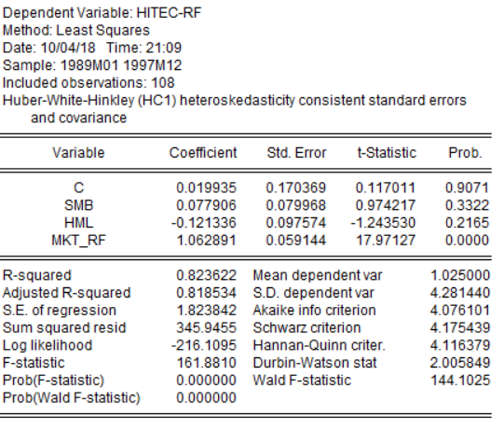

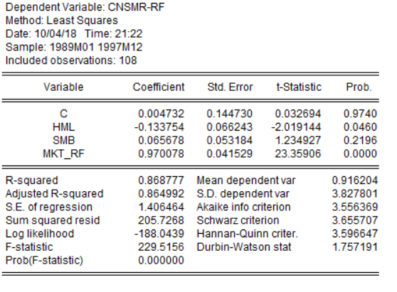

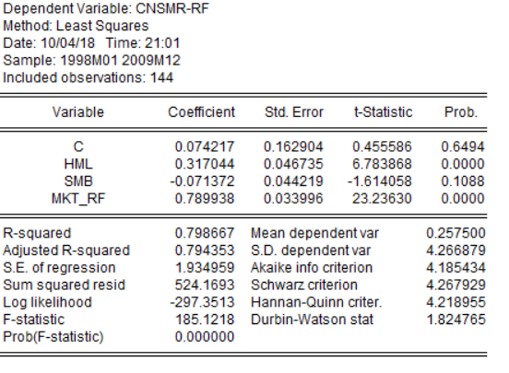

FF model cnsmr period 2

FF model hitec period 2

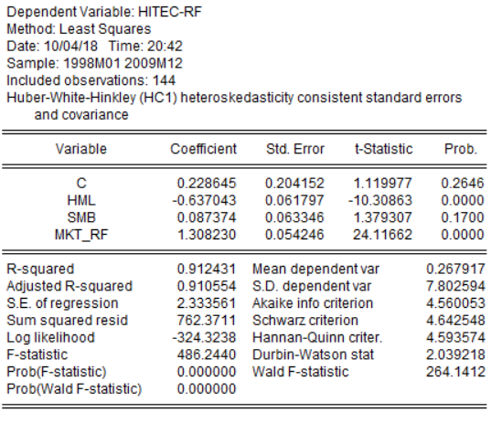

Restricted model for period 1 hitec

Restricted model for period 1 cnsmr

BG test for cnsmr period 2

Restricted model for period 2 hitec

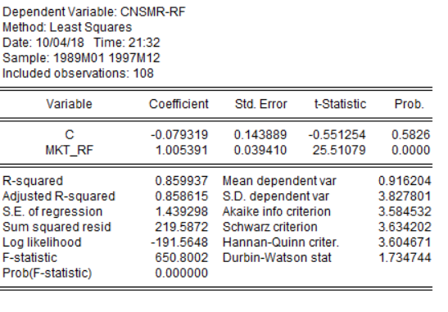

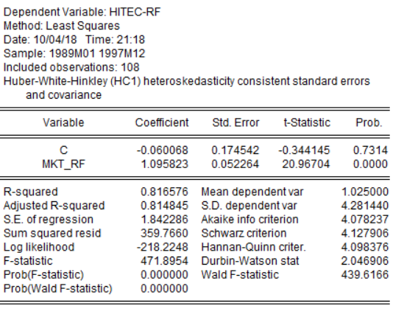

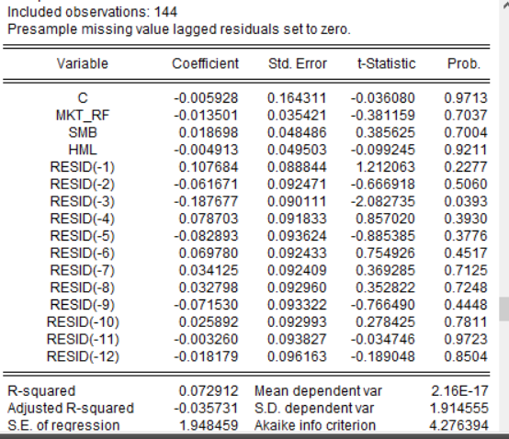

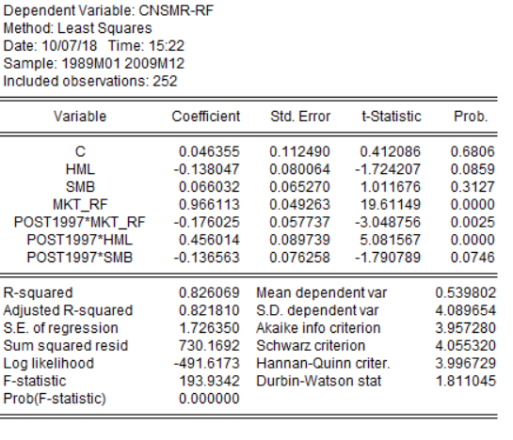

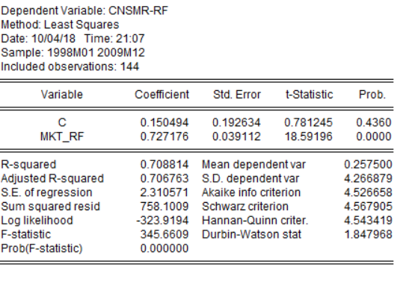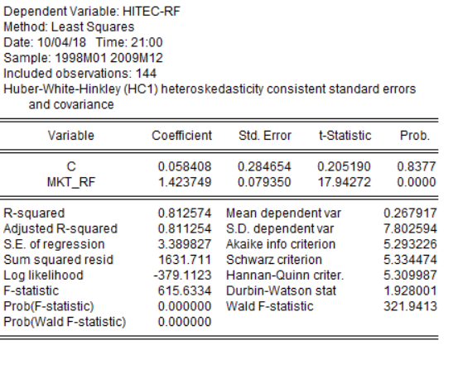

Restricted model for period 2 cnsmr

Dummy variable F test for cnsmr

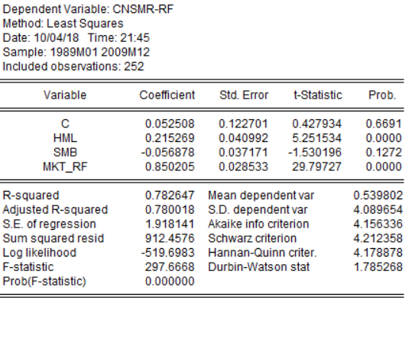

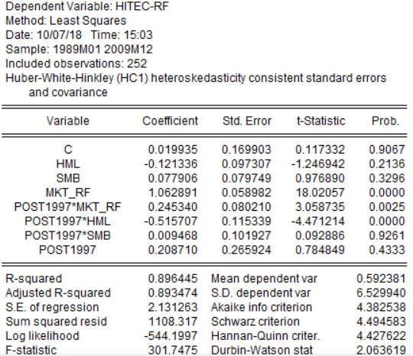

Dummy variable F test for hitec

